EE256 ASSIGNMENT 1

Name: Aradhya VG
Section: S2
Roll Number: 221EE209
Registration Number: 2210059
Subject Code: EE256
Subject Name: Signals and Systems

Q1) Sketch y(t) = x(t) * g(t) for the range –4 to 4 clearly.
- Matlab Code:

x = inline(['(-t-5).*(t>=-5 & t<-4)+(t+4).*(t>=-4 & t<-3)'+(-t-3).*(t>=-3 & t<-2) +(t+2).*(t>=-2 & t<-1)'+(-t-1).*(t>=-1 & t<0) +(t).*(t>=0 & t<1)'+(-t+1).*(t>=1 & t<2)+(t-2).*(t>=2 & t<3)'+(-t+3).*(t>=3 & t<4)+(t-4).*(t>=4 & t<5)'],'t');

g = inline('((t-1).*(2/3)).*(t>=1 & t<=4)+3*(t>=5 &t<=7)');
dtau = .005; %defines an incremental value for the convolution
tau= -8:dtau:8; %defines the integrating ranges for the convolution
ti= 0; %initialising the index counter, i.e. pointer to the solution to DE in y
tvec = -4:.1:4; %defines time range for the output presentation
y=NaN*zeros(1,length(tvec)); %NAN is not a number (no value is defined as o/p)
for t = tvec % Start of loop for convolution, here t is scalar value varies in loop
ti=ti+1; % incrementing the counter pointer for the solution to DE in y
xh= x(tau).* g(t-tau); % Multiplication of two signals
y(ti) = sum(xh.*dtau); % integration
subplot(3,1,1),plot(tau,x(tau),'k-',tau,g(t-tau),'k--',t,0,'ok');

axis([tau(1) tau(end) -3 3]);
subplot(3,1,2),plot(tvec,y,'k',tvec(ti),y(ti),'ok');

axis([tau(1) tau(end) -3 3]);
drawnow;
end
subplot(3,1,3)
plot(tvec,y)
xlabel('t -->')
ylabel('Convolution')

Output:
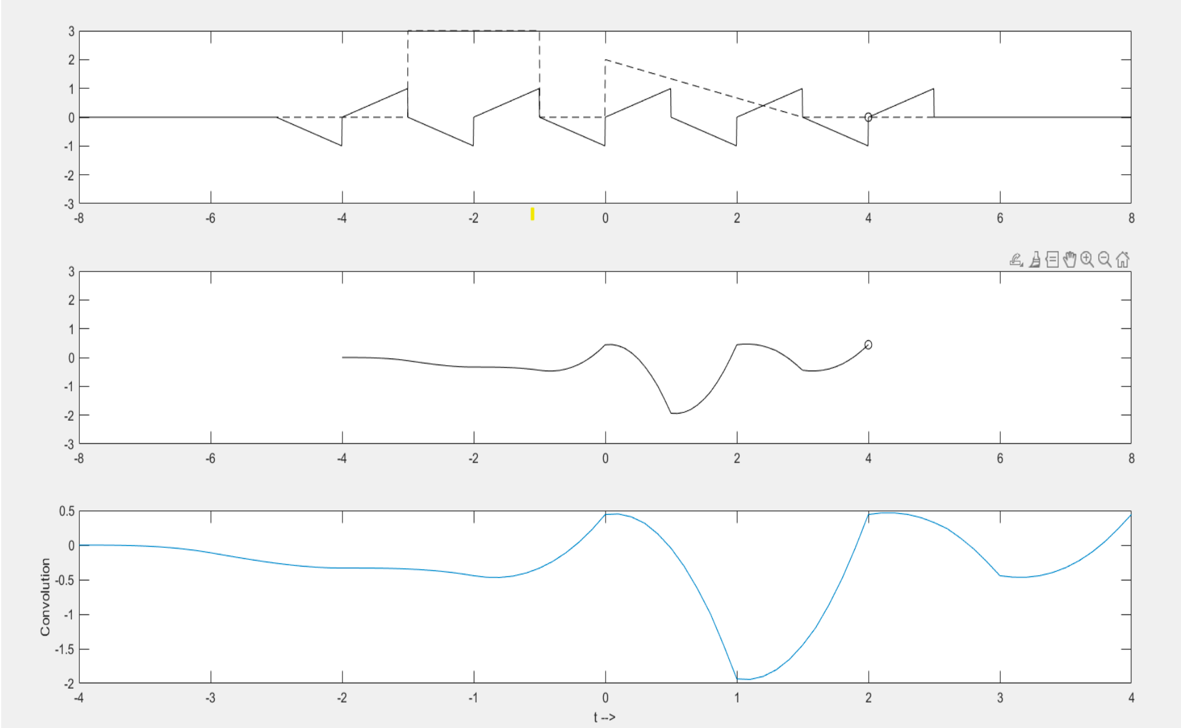
Q2)Also tabulate for all continuous time ranges, clearly the “integrating time ranges” (upper and lower limits) & “function to be integrated” respectively. so that the mathematical expression to y(t) = x(t)*g(t) (consider x(τ) and g(t- τ )) can be found out.

continuous  time ranges | Integrating  time ranges | function to be  integrated
[-1 ,0] | [-4+t,-1+t] | 2/3*(t-tau-1)*[(tau+2)u(-1-tau)u(2+tau) + (-tau-3)u(-2-tau)u(3+tau) + (tau+4)u(-3 tau)u(4+tau) +(-1-tau)u(-1+tau)u(-tau)]
[0,1] | [-4+t,-1+t] | 2/3*(t-tau-1)*[(tau+2)u(-1-tau)u(2+tau) + (-tau-3)u(-2-tau)u(3+tau) + (tau)u(tau)u(1-tau)+(-1-tau)u(- 1+tau)u(-tau)]
[1,2] | [-4+t,-1+t] | 2/3*(t-tau-1)*[(tau+2)u(-5-tau)u(6+tau)+(-1-tau)u(-1+tau)u(-tau) +(1-tau)u(-1+tau)u(2-tau) +(tau)u(tau)u(1-tau)]

*Here rectangular pulse part of g(t) is not considered while integrating as the effective area of x(t) under period 2 is 0 .So multiplying it with constant value won’t make a change.

Q3) Find the mathematical expression for at least two ranges and verify the result using MATLAB.
